|  |
| --- |
| bmilogo.png |



# Acknowledgements

R/C Desk Pilot has been available to everyone for a little over a year now and the community has been extremely helpful. So I would like to thank everyone for their feedback and patience with the earlier versions. At the risk of forgetting someone I would like to especially thank the RCGroups.com community: (all names RCGroups usernames) [Metman](http://www.rcgroups.com/forums/member.php?u=273795) for his meteorological expertise and countless hours of testing together with [Eves](http://www.rcgroups.com/forums/member.php?u=289977) (who on the side builds amazing add-on planes). They are both responsible for reporting countless bugs, so you won't have to :). A thank you for [ggunners](http://www.rcgroups.com/forums/member.php?u=8988), [frankyfly](http://www.rcgroups.com/forums/member.php?u=41344), [Elam\_Serber](http://www.rcgroups.com/forums/member.php?u=294071) and [mariopilot808](http://www.rcgroups.com/forums/member.php?u=333425) for taking the time and gamble of creating wonderful airplanes for RCDP while it was still in beta. I'm sure everyone will enjoy them.

I was also surprised by the R/C entrepreneurs who contacted me and showed interest in the project. The R/C business is full of nice people!

And last but not least I would like to thank my wife, Katleen, for putting up with me while spending evening after evening behind the desk and our little girl Lotte for making me laugh when I got frustrated with another untraceable bug.

I hope you all enjoy this version of R/C Desk Pilot!

Davy

Table of Contents

[Acknowledgements 2](#_Toc276062164)

[Introduction 4](#_Toc276062165)

[Installing R/C Desk Pilot 4](#_Toc276062166)

[System Requirements 4](#_Toc276062167)

[Controllers 4](#_Toc276062168)

[A standard USB joypad or joystick 4](#_Toc276062169)

[An interface cable for your transmitter 4](#_Toc276062170)

[A dedicated dummy R/C controller 5](#_Toc276062171)

[Download & Installation 5](#_Toc276062172)

[Starting to fly 6](#_Toc276062173)

[Configuring the controls 7](#_Toc276062174)

[Your first flight 8](#_Toc276062175)

[The aircraft 10](#_Toc276062176)

[Changing the flight conditions 11](#_Toc276062177)

[The 'flight conditions' menu 11](#_Toc276062178)

[Flight Conditions Presets 12](#_Toc276062179)

[Soaring 13](#_Toc276062180)

[Thermal soaring 13](#_Toc276062181)

[Slope soaring 13](#_Toc276062182)

[Having fun! 15](#_Toc276062183)

[Challenges 15](#_Toc276062184)

[Pylon racing 15](#_Toc276062185)

[Scarecrow 15](#_Toc276062186)

[3D! (as in the 3rd dimension) 16](#_Toc276062187)

[Flying at the club 16](#_Toc276062188)

[Installing add-on aircraft 16](#_Toc276062189)

[Appendix 1: keyboard commands 17](#_Toc276062190)

[Appendix 2: improving frame rate 17](#_Toc276062191)

# Introduction

Thank you for trying R/C Desk Pilot!

R/C Desk Pilot is a free-to-play simulator that aims to raise the bar for free R/C flight sims. Its main goal is to deliver a realistic flying experience without reducing the fun-factor. Since I'm not in the business of selling boxed versions, I can release new updates often. So be sure to check the website <http://rcdeskpilot.com> regularly.

# Installing R/C Desk Pilot

## System Requirements

You will need the following to run R/C Desk Pilot smoothly:

* Microsoft Windows XP/Vista/7, 32- or 64-bit version
* A 1.6 GHz CPU or higher
* A DirectX 9 compatible video card with 128 Mb of RAM
* Microsoft DirectX 9.0c and .NET Framework 2.0 (included in installer)

## Controllers

To enjoy flying R/C Desk Pilot in a realistic manner, you'll need a controller that resembles a real R/C transmitter. There are several options available, depending on your preference and owned equipment.

### joypad.pngA standard USB joypad or joystick

If you're just checking out RCDP or the R/C hobby in general, and you've got a joypad lying around, you can use it without having to invest another cent. The kind that resembles a real transmitter the most are the ones with two analog sticks. Keep in mind that these never have the sensitivity and amount of control that any of the other options below have. So if you're planning on flying a real airplane, it is highly recommended to go for a more lifelike alternative.

### An interface cable for your transmitter

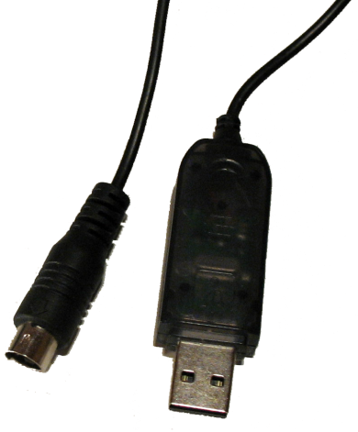If you've already got a real transmitter, you can connect it to your PC and use it in R/C Desk Pilot. To do this, you'll need an 'interface cable'. One end of the cable plugs into the trainer port of your transmitter, the other end into the USB port of your computer. Be careful! Every brand, and usually even every type of transmitter requires a different cable. Be sure to check that the cable is compatible with your transmitter before ordering one. You can usually find a cable for under 10 dollars or euro. If Google doesn't result in finding one, you can ask someone on an R/C forum like [http://www.rcgroups.com](http://www.rcgroups.com/). The upside of an USB interface cable is that you can practice flying (and mixing if you have a computer transmitter) using your real controller. This will give the most realistic feel to flying. The downside is that you'll be using the batteries from your controller (albeit less than while flying), so you'll be charging more often.

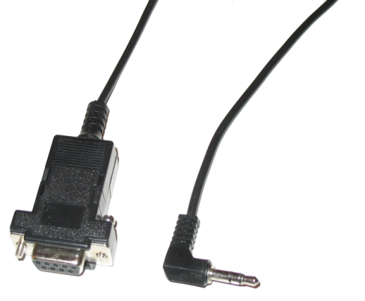All cables sold presently have a USB interface and are basically plug & play. It is possible however that you've already got a cable of the (older) serial DB-9 type. These plug into the serial or COM port of your pc and require some extra software before they can be used in R/C Desk Pilot. You'll need PICJoy and PPJoy to convert this serial device into a standard game controller that can be used by RCDP. An excellent description of this process can be found here: <http://sim.tomsrc.com/page.php?17>

On some transmitters you can get away with a simple stereo or mono audiocable that plugges into your soundcard. You'll need the free [SmartPropoPlus](http://www.smartpropoplus.com) and PPJoy. More details about this can be found here:  
<http://www.smartpropoplus.com/dnn/SetUp/InstallationGeneric/tabid/68/Default.aspx>

### usb_controller.pngA dedicated dummy R/C controller

If you're thinking of flying more often, you might want to consider buying a dummy R/C controller. These resemble a real transmitter, but instead of an antenna, they're equipped with a USB cable. These controllers are plug & play and don't require batteries to run. Of course they don't have all the options of a real computer radio. They can be found in 4 & 6 channel versions. With the 6 channel ones you'll be able to control flaps and retractable landing gear with the controller. They can be found for around 30 dollars or euro.

## Download & Installation

Browse to <http://rcdeskpilot.com/download> to download the latest version. After download browse to the download folder and double-click the rcdeskpilot\_013.exe icon.

The installer will start and present you a standard installation wizard. The wizard may offer to automatically download and install DirectX or the .NET Framework. It is highly recommended to let the installer do so, since the simulator requires these specific versions of both libraries.

# Starting to fly

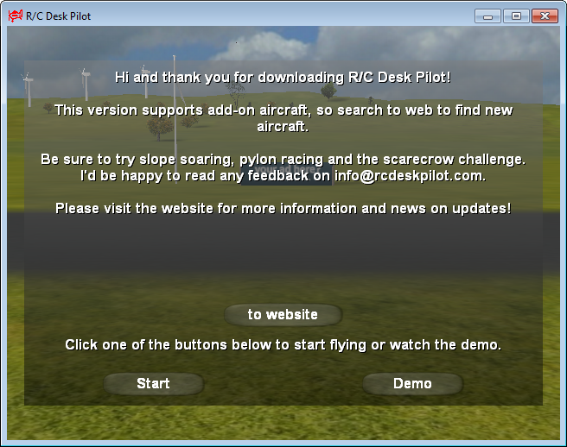Once you've installed R/C Desk Pilot, you'll find it in the Start menu. Click on "R/C Desk Pilot" to start the sim. After startup, the flying field comes into picture:

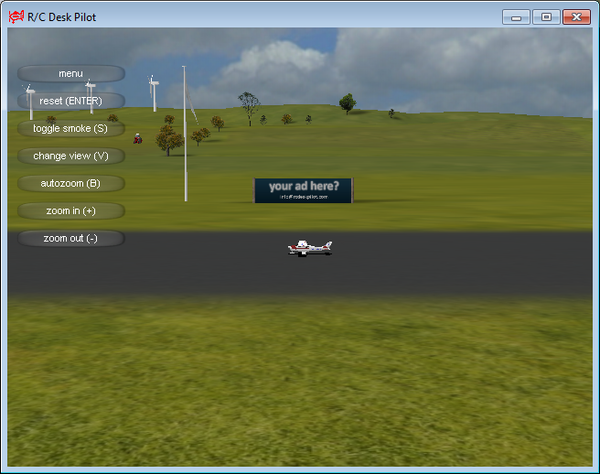The text shown at startup is downloaded dynamically from the R/C Desk Pilot website and will contain information about available updates, so be sure to read it every once in a while.

Click the Start button to proceed.

**Tip**: pressing the Alt and Enter key simultaneously to put the simulator in full screen mode.

## 

## Configuring the controls

Before taking off, you would want to configure your controls. You will only have to do this once. Note that the in-flight menu automatically appears when moving your mouse over the sim window.

Click on the 'menu' button. We'll go over the entire menu later on in the manual, for now, click on the button labeled 'controls'.

The first thing you need to do is calibrate your controller. This is so that the center and throw of your sticks are well defined. Click the 'Calibrate' button and the standard Windows dialog appears displaying the attached controllers. Select your controller and click the 'Properties' button. On the dialog box that appears, select the 'Settings' tab. Click the 'Calibrate...' button to start the calibration wizard. The wizard will ask you to move your sticks around several times. Follow it and after finishing, return to the sim.

Now that your controller has been calibrated, you should be able to see the sliders on the right of the menu move in conjunction with your sticks. The first decision you'll have to make is what control channel to assign to which stick movement. There are lots of options, but the most commonly used are what's called 'mode 1' and 'mode 2'. It's best to ask your R/C club what mode people are using there so they can train in the same mode. On a transmitter, the throttle stick won't have a centering spring so you can deduct its mode from that.

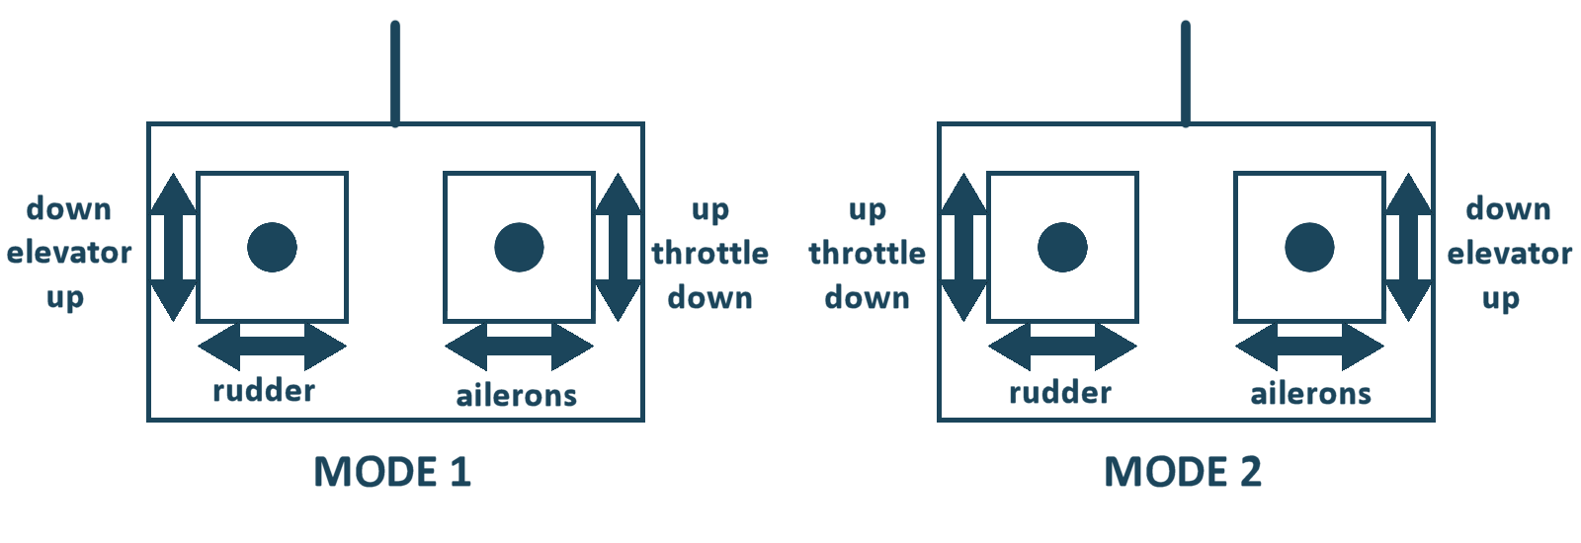

The procedure to set the control assignments is to move the stick you want assigned to a channel, see which of the control input sliders is moving, and assign that number to the channel. Check the 'invert' checkbox if the controls are reversed. The 'expo' checkbox makes the controls less sensitive around the center and gradually more towards the extreme. This is especially handy for very twitchy planes.

Once everything is set up, you can return to the sim and are ready to fly!

## Your first flight

If you've flown an R/C plane before, you know what to do now. If not, the following is a very basic introduction. Before flying an actual aircraft, always get the help of an experienced pilot.

Start with the included Cessna. This is a high wing (and thus more stable) electric foamie with aileron control. Zoom in on the airplane and watch the control surfaces move with your stick inputs. The ailerons control the bank angle (or roll) of the airplane, the elevator the pitch and rudder the yaw.

You should always take off into the wind. By default, no wind is present in the sim, so smoothly increase the throttle stick to full. While rolling on the ground, correct your heading by using the rudder stick (this is also linked to the steerable nose wheel). As your speed increases, gently pull back on the elevator stick to get the plane off the ground and start a gentle climb. Once in the air, keep your wings level by using the ailerons. You'll notice that before long, the airplane becomes very small. This is the same in real life: you can't keep flying straight for long before losing sight of your plane. So it's time to make the first turn.

On a 4-channel airplane, turning isn't done by the rudder as you might expect. Without dihedral, the rudder isn't very effective at changing the heading of an airplane. Make your first turns using only aileron and elevator input. Apply aileron to get the plane to a bank angle of about 30°. You'll need to apply up elevator to keep the plane from losing altitude. Automatically the plane will start to turn. Apply aileron to level the plane once the desired heading has been reached.

Landing an airplane is the hardest part. Slow the plane down and turn into the wind. Remember that it's not the elevator that controls the altitude of an airplane. If you apply too much elevator at too slow an airspeed, the airplane will stall and simply fall out of the sky. While landing, use the elevator to control airspeed and throttle to control altitude. Keep the airspeed high enough so you don't have to apply full elevator during the descent. Gently ease the airplane to the ground and right before touchdown, increase elevator and reduce throttle to idle to flare the airplane and land it as softly as possible. If you can do this in the simulator, you'll have greatly increased the chances of bringing home you real airplane in one piece on your first flight.

# The aircraft

R/C Desk Pilot comes with a variety of aircraft pre-installed. You can access them from the 'aircraft' menu.

|  |  |
| --- | --- |
| icon.png | The **Cessna** is an ideal trainer if you're planning on flying motorized airplanes. It's a high wing foam airplane with ailerons that will teach you all the basic moves of an airplane with reasonable stability. |
| icon.png | The **Extra** is the classic aerobatic airplane. Not for the faint of heart. |
| SF260_icon.png | The **SF.260**: a nitro powered plane equipped with retracts and flaps. Also available in micro version. |
| icon.png | A 6mm depron profile **P-51** warbird. |
| icon.png | The 2 meter **thermal soarer** comes in two versions: with and without motor. |
| slopesoarer.png | The **slope soarer** is a fast, 4 channel glider ideal for catching wind on top of a hill. |
| icon.png | The **Tiger** comes in two variants: as a gas-powered variable pitch helicopter and as a simple-to-fly coaxial. |

# Changing the flight conditions

Without doubt the most advanced feature of R/C Desk Pilot is its ability to simulate a multitude of flight conditions, more specifically wind and thermal activity. This should make the simulator especially interesting for glider pilots and offer challenging and realistic flight conditions for other aircraft. The wind/thermal model was developed in collaboration with meteorologist (ret) [Metman](http://www.rcgroups.com/forums/member.php?u=273795).

## The 'flight conditions' menu

Set the wind and sky conditions for your flight using this menu. The following controls are available:

|  |  |
| --- | --- |
| Control | Description |
| Presets selection submenu | *Preset flight conditions* by time of day and for three different wind speed classes. See below. |
| Customize Button | Use this button to customize each of the presets to your liking. |
| Wind speed | *0 to 43 kph* |
| Wind direction | *0 to 360*. Once set or reset, it will apply to all other settings and presets and will be remembered on sim start up. |
| Gust strength | *0 to 43 kph*. This is the maximum gust strength. Gusts are additive to wind speed. |
| Gust variability | *Predictable to very unpredictable* in both direction and speed |
| Gust frequency | *Low to high* |
| Turbulence | *Light to heavy*. Turbulence diminishes with altitude to zero at 50 meters. |
| Thermal size | *Small to large*. Not active when Thermal Strength is set to off. |
| Thermal strength | *Off to strong*. When off, the thermal size slider is not active.  Note that under the Scenery menu item of the sim main menu, you can enable visual representation of thermals. |
| Downdrafts | *Off to realistic*. Not active when Thermal Strength is set to off. |
| Sky Condition submenu | Five sky conditions are available – *sunrise, late morning, mid-afternoon, sunset and moonlight*. This control will override the preset sky condition for your session. |

### Flight Conditions Presets

For convenience, there are 15 meteorologically-realistic presets simulating wind, gust, turbulence and thermal conditions for sunrise, late morning, mid afternoon, sunset, and moonlight. They are preset for three different typical flying-day wind speed ranges; light airs, breezy and windy.  These presets simulate conditions for a typical summer day with strong afternoon thermals and have skies more or less suited to the time of day.

Presets can be modified for each session but cannot (yet) be saved.  On startup, RCDP will remember the preset last used. Choosing the “no weather” preset sets all controls to zero or off, and leaves the wind direction as is.

If you’re new at RC flying, start off just as you might with an early morning maiden of your new plane by choosing the morning/light airs preset and doing your test “crashes”. If you want a challenge flying and landing, choose a cross wind direction on a breezy or windy afternoon and hang on! Try slope soaring in the evening with a nice steady wind. Soon you’ll find the preset you most enjoy flying. If you have questions about the presets, please contact [Metman](http://www.rcgroups.com/forums/member.php?u=273795) on RCGroups.

# Soaring

## Thermal soaring

This section describes the different options you have to simulate a fun and realistic thermal soaring session.

Start by selecting a sailplane from the 'aircraft' menu. The default planes contain an electrically powered and unpowered version of a 2 meter thermal sailplane. The electrically powered version can climb under its own power. Getting the unpowered version in the air requires the help of a tow plane. You can start a tow by pressing the 'T' key on your keyboard. When reaching a good altitude the cable will disconnect automatically. If you want to release the cable sooner, you can do so by pressing the 'T' key again.



Now that you've got the sailplane in the air, it's time to hunt some thermals!

Of course the amount, size and strength of thermals strongly depend on the flight conditions. So select a flight condition from the 'flight conditions' menu with some thermal activity. The highest thermal activity occurs in the mid-afternoon presets when there's not too much wind. Of course, the rising air has to come from somewhere, so around the thermal there is sinking air or downdrafts that will make your plane lose altitude faster. Get the glider moving slowly and watch the wings. Soon they will tell you where the lift is, so turn into it and circle to catch the lift. You might even be surprised by a boomer or two.

RCDP has a couple of other ways to help you detect thermals. When the sailplane is equipped with one, you can enable a variometer. The variometer will produce a tone that indicates whether the airplane is climbing or descending. You can enable or disable the variometer in the 'sound' menu.

The second way to detect thermals is visual. Open the 'scenery' menu and check the 'enable visual representation of thermals' checkbox. With this option enabled, bubbles will rise from places with thermal activity.

## Slope soaring

The other way to keep a sailplane in the air without an engine is wind. Wind blowing up a slope that is. R/C Desk Pilot dynamically calculates the wind vector based on the wind speed, direction and terrain. So wind blowing against a slope will rise, to sink again on the leeward side. Of course the effect of the slope diminishes with altitude. This effect can keep a sailplane aloft.



Slope soarers are usually faster and sleeker gliders than thermal sailplanes to be able to handle the high winds. RCDP contains a aileron-equipped slope soarer. Select it from the aircraft menu and head over to the flight conditions menu. Select a preset with lots of wind. The wind direction is critical in how much lift is generated on a certain slope. Set it to 'west' as the west side of the slope in the scenery is best located for slope soaring. After selecting the flight conditions, go to the 'scenery' menu. There you will find a dropdown list for 'pilot position'. Select 'Top of the hill (slope)' and go back to the sim. You will find yourself on top a hill. Reset the flight to relaunch the airplane into the wind and try to keep the plane aloft. Always turn into the wind or the glider will quickly fly over the hill into sinking air. When you get good at that, try finding other spots that have lift, but stay clear of the windmills!

# Having fun!

Although most people see a simulator as a way of saving a few trips to the hobby store to buy a new plane, it should also be fun. After all, all hobbies should be.

## Challenges

Once you've mastered keeping the plane in the air, you can move on to other objectives. R/C Desk Pilot offers two fun challenges (with more to come).

### Pylon racing

The first challenge is pylon racing: fly through the 7 pylons as fast as you can. The difficulty is keeping your plane low enough without digging holes in the ground. The clock starts when you pass through the first gate and stops when you pass through gate 7. If you've missed a gate, you can reset the clock and start over by flying through the first one again. Be sure to switch to tail cam or chase cam view for this one. You can use whichever plane you like, but faster planes tend to turn slower...

### Scarecrow

If you've been in the hobby long enough, you've had your fun with birds. You can chase them, thermal soar with them, they can grab your plane out of the sky...

In the sim, you can have fun with a whole bunch of them. The scarecrow challenge sets you up amidst 3 cornfields. It is your job to protect the crops against a flock of 100 birds who haven't had their lunch yet. You can do that by flying into the flock and scaring them away. Unfortunately they're a very aggressive breed of birds and won't stay scared for long. See how long you can keep the cornfields safe...

## 3D! (as in the 3rd dimension)

With R/C Desk Pilot you don't need special 3D monitors or video cards to do 3D (although it is perfectly compatible with the Nvidia 3D drivers). A simple pair of red/cyan glasses like the ones on the left is enough. They can even be made of cardboard. Go to the menu and open the 'graphics' settings. Check the checkbox marked 'Enable anaglyph 3D'. That's it! You can put on your old-fashioned red/cyan glasses and enjoy the simulator in three dimensions. Of course for each frame displayed on screen, the pc has to produce two in the background (one for each eye). So expect the frame rate to drop a little.

## Flying at the club

To simulate a real R/C club where there's constantly airplanes buzzing around, you can add a few computer controlled aircraft. Open the menu and go into the 'simulation options' screen. Add a number of other pilots and head back to the sim. You'll see and hear other planes flying around.

# Installing add-on aircraft

This version of R/C Desk Pilot comes with the ability to design and tweak your own airplane using a 3D modeler and the included Aircraft Editor (the manual of the editor is a separate document). As a result, people have started sharing their own creations for others to enjoy. At the time of release already a few dozen airplanes were available for download throughout the internet. Check [the website](http://rcdeskpilot.com/) for some links.

To install a new airplane:

1. Download the airplane from the internet. This usually comes in the form of a .zip archive.
2. The archive will contain a folder named after the airplane. In your Documents folder, you'll find a folder named "RC Desk Pilot", this contains another subfolder named "Aircraft". Extract the airplane archive into that folder.
3. That's it! The next time you start the simulator, another airplane should be in the list!

# Appendix 1: keyboard commands

While in flight:

**+** : increase zoom  
**-** : decrease zoom  
**Enter** : reset aircraft and start position  
**s** : toggle smoke  
**v** : toggle camera through various views  
**b** : autozoom - this will keep the aircraft the same size on screen, irrespective the distance  
**i** : show extra information (frame rate, speed, altitude)  
**F12** : toggle wind vectors - this will display the wind vector in the vicinity of the aircraft  
**Esc** : exit the sim  
**f** : toggle flaps (when equipped)  
**g** : toggle landing gear (when equipped)  
**t** : toggle tow plane (for sailplanes)

Aircraft control (when no controller is attached):

**Numeric keypad 1** : rudder left  
**Numeric keypad 3** : rudder right  
**Numeric keypad 2** : elevator down  
**Numeric keypad 8** : elevator up  
**Numeric keypad 4** : aileron left  
**Numeric keypad 6** : aileron right  
**Numeric keypad 7** : throttle idle  
**Numeric keypad 9** : full throttle

# Appendix 2: improving frame rate

Since R/C Desk Pilot uses full 3D environments and shaders for some graphical effects, you might experience performance problems when running the sim on older systems. Here are some tips to improve the frame rate:

1. **Run in full screen mode**. If the sim has the full screen to itself, it will perform better, especially on systems with a single core CPU. You can enter full screen mode via the 'graphics' menu or by pressing 'ALT' and 'Enter' on the keyboard simultaneously.
2. **Reduce the resolution.** If you're still having a low frame rate in full screen you might want to reduce the resolution in 'graphics' menu.
3. **Switch off 'dynamic scenery'.** By switching off 'dynamic scenery' in the 'scenery' menu, you might notice an improvement in performance. Dynamic scenery is what adds birds, the tractor and waving flag to the scene.
4. **Reduce graphics quality.** Besides turning off dynamic scenery, you can reduce the strain on the system further by dialing down some other options: in the menu, open the 'graphics' settings. Reduce 'smoke detail' to low (or don't use smoke). As a last resort, you can select the 'low' scenery detail setting. This will greatly improve performance, but the pictures won't look great. Also, avoid enabling the wind vectors (using the F12 key).